**Predicting Heart Failure using Machine Learning**

(binary classification problems)

IST 687 – Introduction to Data Science

Adrian Torres

Paige Madison

Frank Williams

**Table of Contents**

Introduction .........................................................................................

Business Questions ..............................................................................

Data Cleanse/Munge/Preparation...........................................................

Descriptive Statistics & Visualizations ....................................................

Data Modeling & Visualizations...............................................................

Summary................................................................................................

Appendix – R Code...................................................................................

**Introduction**

**Business Questions**

**Data Cleanse/Munge/Preparation**

**Descriptive Statistics & Visualizations**

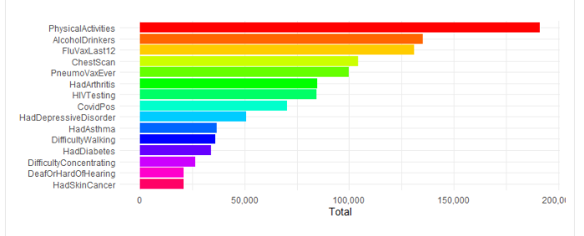

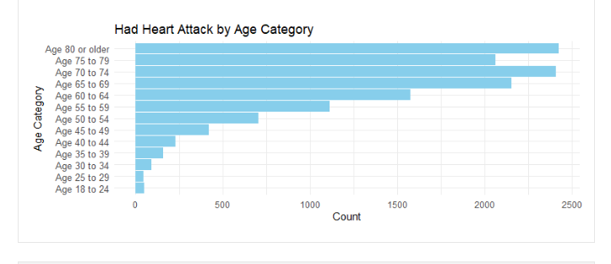

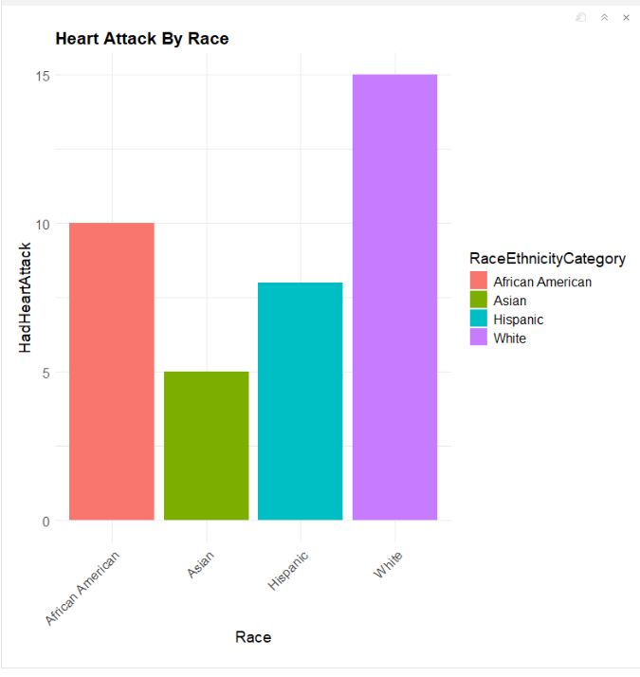

**Correlation Statistics -**

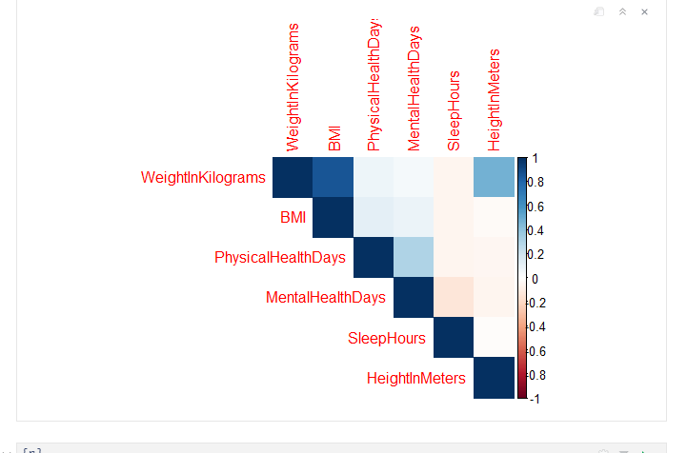

Data Modeling & Visualizations

Regression Model -

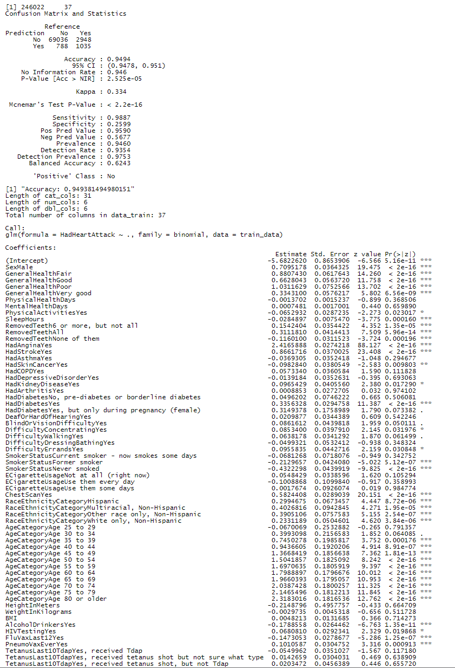

Summary

Machine Learning Algorithms Used and Explanation

First, relevant columns were selected and excluded, and data types of each column were verified. Specifically, the column “State” was excluded as it didn’t appear to be relevant to predicting heart attacks.

After, a data subset was created, which converted categorical variables in usable factors and Nas were removed from that subset. Next, the data was split using 70% of the data to train and 30% to test. Then a logistic regression model was fit using the training data.

Figure 1: Logistic Regression Output

# Referenced Equations

$$Accuracy=\frac{\left(TP +TN\right)}{\left(TP+TN+FP+FN\right)}=0.9494$$

$$Balanced Accuracy=\frac{\left(Sensitivity + Specificity\right)}{2}=0.6243$$

$$Sensitivity =\frac{\left(TP\right)}{(TP+FN)}=0.9887$$

$$Specificity =\frac{\left(TN\right)}{(TN+FP)}=0.2599$$

$$Positive Predictive Value \left(Precision\right)=\frac{TP}{\left(TP + FP\right)}=0.9590$$

$$Negative Predictive Value =\frac{TN }{(TN + FN)}=0.5677$$

The model output for the logistic regression showed the following:

* There were 69,036 true negatives (TN) or correctly predicted “No” values.
* There were 1,035 true positives (TP) or correctly predicted as "Yes" values.
* There were 788 false positives (FP) or incorrectly predicted as "Yes" values.
* There were 2,948 false negatives (FN) or incorrectly predicted as "No" values.

The accuracy was 0.9494 or 94.94% for our logistic regression model which meant that it correctly classified 94.94% of the time. The Balanced Accuracy suggests that even with an imbalanced data set, or the amount of “No” values outnumbering the “Yes” class, it still managed to score above a score of 0.5, which would be equivalent of guessing.

The No Information rate, or the proportion of predicted values that belong to the majority class, was 94.6%, which meant of the predicted outcomes 94.6% was the majority class (i.e., the “No” class) .

The P-Value[Acc>NIR] has a value of $2.525*{10}^{-5}$ suggests that the model’s No Information Rate was significantly different from the Accuracy value.

Cohen’s Kappa value considers the possibility of agreement between the actual and predicted classes happening by change and has a scale from -1 to 1. Our model had a Cohen’s Kappa value of 0.334, which suggested poor agreement between the actual and predicted classes.

The Mcnemar’s Test’s p-value had a value of $<2.2*{10}^{-16}$ which suggested that there were significant differences between the observed discordant pairs (i.e., FP +FN) and expected discordant pairs (i.e., FP + FN), the latter value is considered under the assumption that our model and a hypothetical copy of our model performed equally.

The detection rate or the proportion of true positive instances (i.e., the number of “No” values), which were detected by the model at a rate of 0.9354, indicates that the model detected 93.54% of positive instances.

The Prevalence, or the measure of the positive class in the dataset, or the amounts of “No” in our data set, was 0.946, which indicates that 94.6% of our instances belonged to the positive class.

The Detection Prevalence is the predicted positive cases by the model and has a value of 0.9753 or 97.53%.

We also ran a decision tree algorithm to see if there was an alternate model that could produce similar results.

Overall, the model produced a similar output with a slightly lower accuracy score, so we kept the logistic regression model. We also tried a 5-fold cross-validation to assess the performance of the model and got the following output.

As can be seen by the accuracy metric, using k-folds did not increase the accuracy score, but did increase the time it took to fit the model using the subset version of our data.

Appendix – R Code